Field & Batting Cage Usage Reservation Request Process

To submit a reservation request form for a Lakes Athletics field or batting cage follow the below process:
- Visit – www.lakesathletics.org
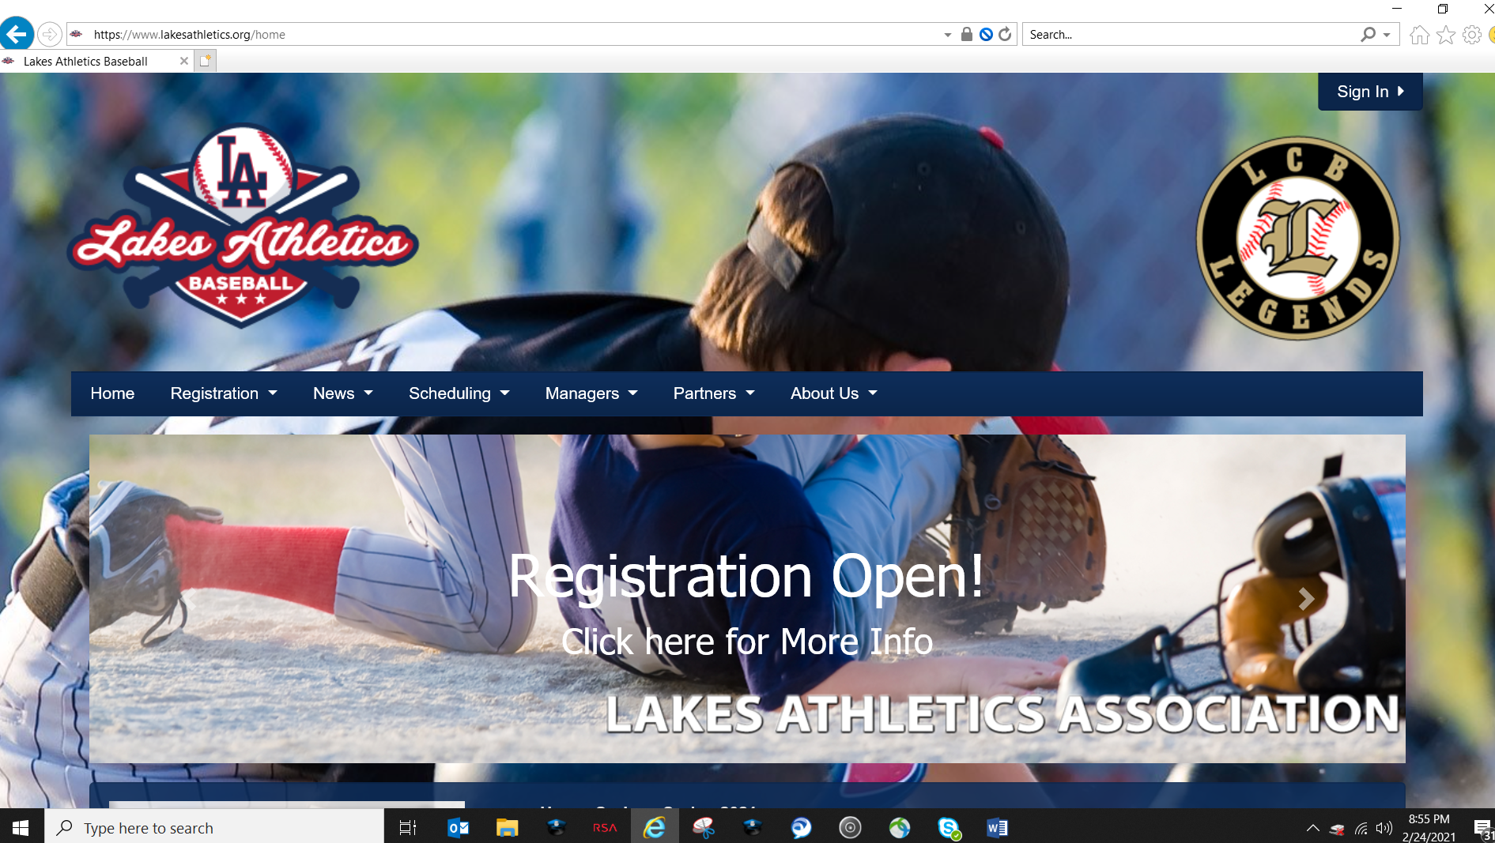
- Confirm field or batting cage availability by viewing league field calendar.
- To view the field calendar select the “Scheduling Tab” and “Calendar”
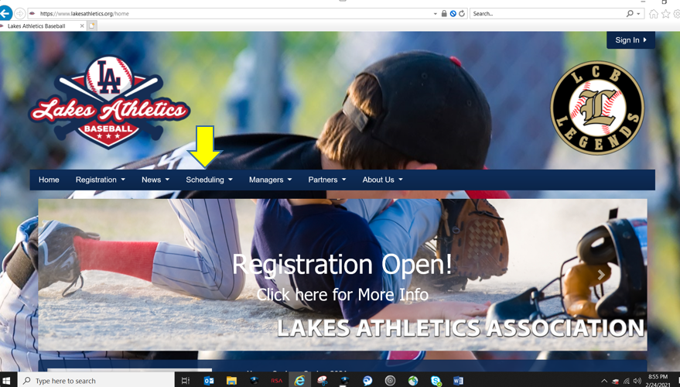
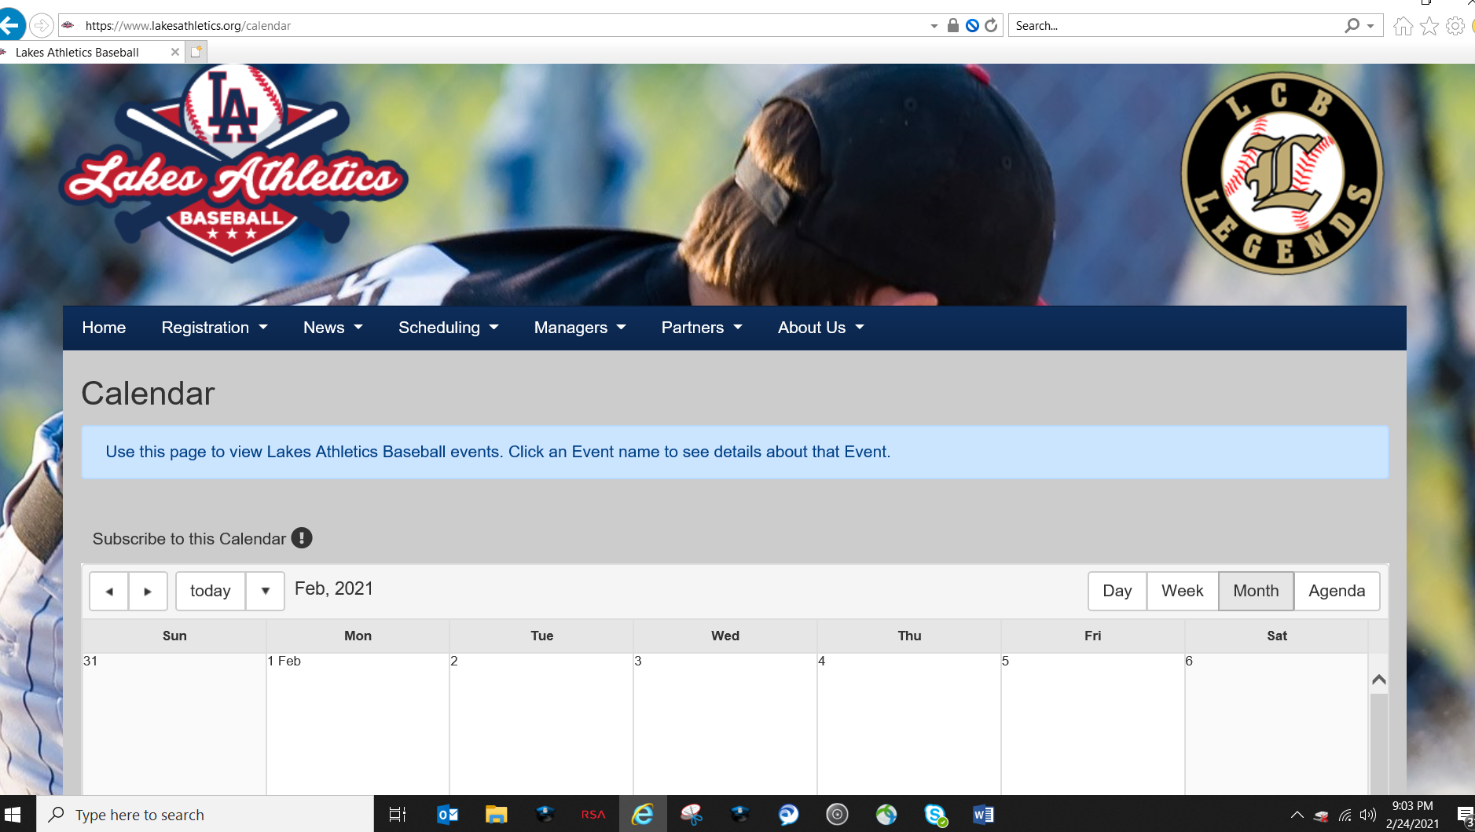
- Within the calendar you can change the views to Day, Week and Monthly. You can select days you would like to practice and confirm field availability.
- Once field availability is confirmed, select the “Scheduling Tab” and “Field Request Form”

- Complete –
  - “Field Reservation Request” Form and “Submit” Form
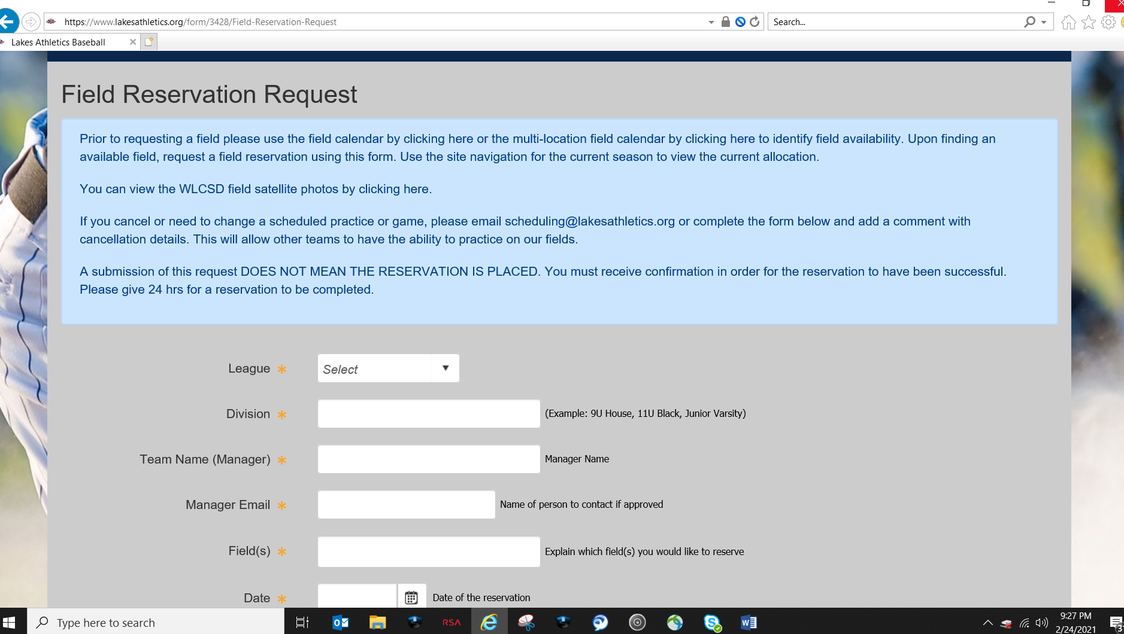
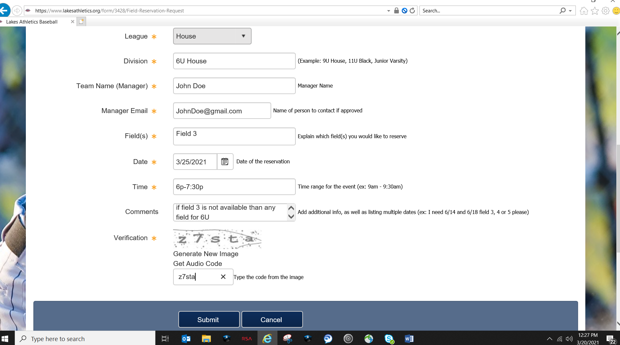
- Complete –
  - “Submit” Form

- You will receive an email confirmation of request

- When Request is approved, your team will be assigned that field on the calendar and you will receive a confirmation email.

